Golf Swing Sequencing with Deep Learning

Wiley A. Jones
Oregon State University
CS 435: Applied Deep Learning
jonewile@oregonstate.edu

INTRODUCTION
Golf is one of the oldest continuously played sports, tracing its history back to the 15th Century in Scotland. Currently, it is estimated that over 138 million people worldwide play golf, including approximately 47 million Americans aged 6+ who participated in some form[1]. However, since its inception, all players have suffered similar frustrations in their pursuit of improvement. The mechanics of a golf swing are complex and multifaceted, leading to countless avenues for adjustments and tweaks to improve the swing. With all these factors to consider at once, it is difficult for beginners and amateur players to grasp what aspect of their swing needs improvement. Ask non-professional golfers why one shot went straight and the other sliced right, and most will not be able to give a satisfactory answer. Swing mechanics are not suitable for complete self-learning without outside help. It requires exterior coaching.
The oldest method of swing improvement in golf involved having someone else watch your swing and give feedback based on naked eye assessments. Golf coaches and pros were especially valuable for their knowledge and experience in identifying swing problems—a difficult task to do in real time. As video technology became more accessible, swing videos became the standard in golf lessons. This allowed everyone to see their swing and make any necessary tweaks. Today, slow-motion videos are utilized more than ever for their ability to reveal subtle facets of a swing that are impossible to see in real time. Alongside these advancements, scientific research into the mechanics and biometrics of golf swings increased dramatically, leading to a deeper understanding of proper technique and form. Yet, despite these evaluations, coaches and pros remain the superior option as they can articulate the issues and solutions for swings the best. Because of this limit in golf improvement, this paper seeks to provide a simple, effective way for anyone to improve their swing by breaking down swing videos into frames that capture the essential parts of the swing sequence.
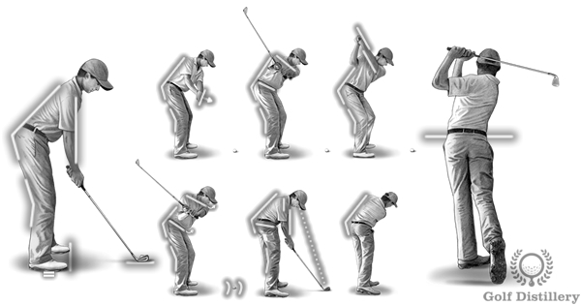
Figure 1: The ideal golf swing. [4]

Swing Sequence Events
The beauty of a golf swing is that all information of a specific sequence can be captured in a single frame, meaning that an entire video of a swing can be broken down into a collection of images. However, these frames should be chosen at distinct points in the swing that define the arc of the entire movement. For this paper, the events will be taken from McNally et al. [2]:
Address (A). The moment just before the takeaway begins, i.e., the frame before the backswing movement is noticeable.
Toe-up (TU). The shaft is parallel with the ground during the backswing.
Mid-backswing (MB). The arm is parallel with the ground during the backswing.
Top (T). The moment the golf club changes directions at the transition from backswing to downswing.
Mid-downswing (MD). Arm parallel with the ground during the downswing.
Impact (I). The moment the clubhead touches the golf ball.
Mid-follow-through (MFT). The shaft is parallel with the ground during the follow-through.
Finish (F). The moment just before the golfer’s final pose is relaxed.
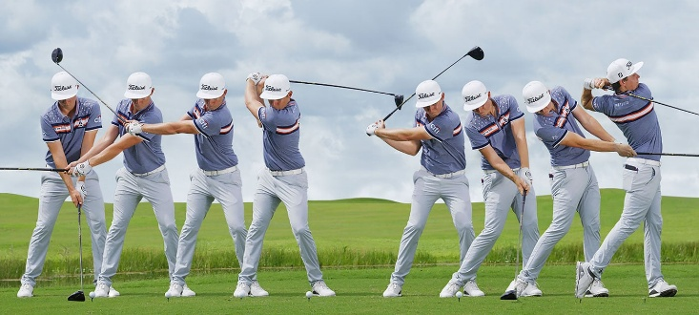
Figure 2: The eight events in a golf sequence from professional golfer Cameron Smith. [3]

Applications
Each of these events is essential for understanding a golf swing, and each provides unique insights into movement. Correctly identifying these moments would be valuable for golfers of any level, as it provides a clear structure for assessing potential issues or areas of emphasis in swing analysis. For coaches, it would save time by eliminating the need to manually scrub through hundreds of videos to find all the crucial moments. Overall, instant access to these sequences would allow faster, more focused training for any golfer.
In the future, as golf research continues to improve, this technology could be combined with pose tracking to map all the critical angles and physical facets of the swing in another application, providing immediate feedback to the user. For example, the front arm of a golfer should remain as straight as possible until impact with the ball. A video of a swing could be uploaded, the important sequences extracted and then run through the body measurements process where it shows that the arm angle becomes too bent from the top of the swing on. The program could relay this feedback upon completion leading to clear actionable improvements without the need of a coach. Overall, this technology could be a game changer in the golf industry, expanding the availability of high-quality training for the average golfer.

DATA
GolfDB is the dataset used for this project [5]. It is a dataset of over 1400 professional golf swing videos collected from the internet. The videos feature a collection of PGA and LPGA tour pros, captured from various angles. The most common angle is the down-the-line, where the camera faces the direction the ball will travel. This view is what television broadcasts of golf tournaments use. The other is the face-on view, where the camera is facing the golfer during the swing. The videos have all been compressed to 160x160 pixels to make them easier to work with. This resolution would be bad for a golf fan watching on Sunday, but it is perfectly suitable for our model.
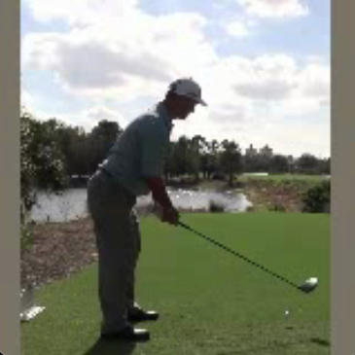
Figure 3: Screengrab of GolfDB video
There are two parts of GolfDB. One is the actual videos, and the other is a tabular CSV file containing information on the golfer, club, and view. Most importantly, it also includes the exact frame numbers for each of the eight sequences per swing, which will serve as the labels for modeling.

Retrieving the Dataset
Both the golf videos and CSV file can be downloaded on this link: https://www.kaggle.com/datasets/marcmarais/videos-160. Also, the original videos, before compression, as well as the code the original GolfDB paper can be found on Github at https://github.com/wmcnally/golfdb. While this project is based on the dataset and ideas presented in the paper from McNally et al. [2], all code and models used are unique to this project. For example, the original modeling was done in PyTorch, while this paper used TensorFlow and Keras libraries.
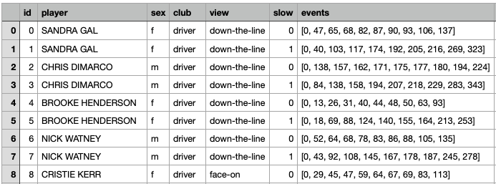
Figure 4: Screengrab of CSV file of GolfDB events
The Kaggle download has the CSV file on the swings with the labels for the swing under the events section. It is an array of frame numbers. The first and last members of the array are the clip’s beginning and ending frames, so they can be ignored during modeling. Items 1 – 8 are the frame numbers for each of the eight swing sequences in order (i.e., 1 is the frame of the approach or 4 is the frame number of the top of the swing). The ID section of the dataset matches the file name for each swing video included in the download. They range from 0–1399, for a total of 1400 individual swings available for modeling.
Luckily, the GolfBD data has already been cleaned and prepared for processing. Running some quick checks on the data shows that there are no missing values or videos. In addition, the videos in the download are all sized to 160 x 160, so no further preprocessing is needed with them. The dataset is ready to be processed.

Data Processing
With the data frame and videos in place, the next step is to determine the model's processing. Since the models in this paper cannot directly use video data, each video must be split into individual frames and fed to the model as batches. To facilitate this, the OpenCV library in Python will be used. OpenCV allows for videos to be captured one frame at a time and saved as individual images—perfect for the situation at hand.
After the frame is extracted from the video, its label will be added and passed to the model. Since there are eight key frames of interest, there are nine total label classes. One for each frame and one for non-event or background. However, this method introduces an imbalance in the data. Each video is hundreds of frames long so that the non-event label will dominate the others in terms of total counts. To combat this imbalance, weights will be applied to the labels during the modeling stage to smooth class imbalances. Based on McNally et al. [2], non-events occur approximately 35 times more than events. For this paper, the label weights will be treated as a hyperparameter and tested to determine which configuration yields the best results.
There are also some differences in processing for the train and test datasets. For the train dataset, only a slice of the original video will be used. The number of frames will be tested for effectiveness, but some initial values are 16, 32, and 64. Data processing will randomize the start point for these slices, and if the capture reaches the end of the video, it will start collecting values from the beginning. This process will increase training speed by limiting the number of frames. It will also help the model avoid bad habits in the temporal and spatial aspects of the swing, since the start of the training images will not always be the beginning. The test data will be the full videos, as, when deployed, that is what the model will be testing on new information.

MODEL
The architecture of this model is a two-step process: a 2D CNN that reads each image in the video sequence. The CNN will extract the features from the video frames and pass them to the rest of the model. These features will include edges, shapes, and objects that will help map where the club and golfer are in the swing. This CNN is a pre-trained model that will be fine-tuned to the videos during training. As stated by McNally et al. [2], using a non-pretrained CNN is not possible because the dataset’s images are too similar. The CNN fails to train because the task of distinguishing them is too difficult for an untrained model. The model used is MobileNet. This model and its weights can be initialized in TensorFlow/Keras by creating a MobileNet instance with the pre-trained weights.

LSTM
The next step in the model will be to address the timing aspect of a golf swing. Because the backswing and downswing are essentially the same motion, just in different directions, purely relying on the image data won’t be enough to accurately identify the correct sequences. Also, many of the video clips involved the buildup to the swing or practice swings that, to a CNN, would be indistinguishable from the approach. The model needs a spatial and temporal component to address these complexities and to understand aspects such as the direction of the club and when the swing truly begins.
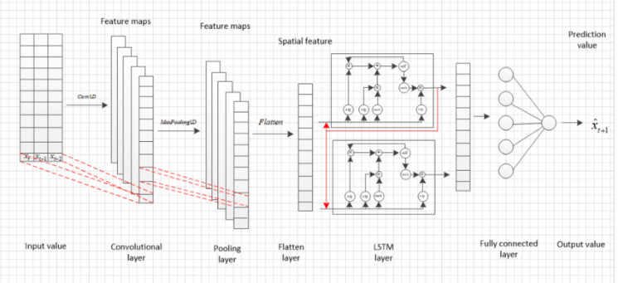Example of a CNN to a LSTM model. [6]
To incorporate this spatial and temporal information into the model, a LSTM (Long Short-Term Memory) is used with feature data from the CNN. LSTMs, and RNNS in general, can extract temporal and spatial features from a series of images by updating their hidden state, which remembers parts of previous data and compares them with the current data. This is perfect for this project, as the golf swing sequences are defined by their temporal and spatial positions relative to the whole swing. This process will take the feature map data from the CNN and connect them in time and space to understand the entire motion of the swing clip. When this is complete, the model will predict whether the current frame is an event frame or a non-event frame.

Transformers
Another approach to image classification is to use a transformer model instead of an LSTM, with feature maps generated by the CNN. Transformers are famous for their abilities in the Natural Language Processing part of Deep Learning, but recent tests have shown them to be capable of image classification.
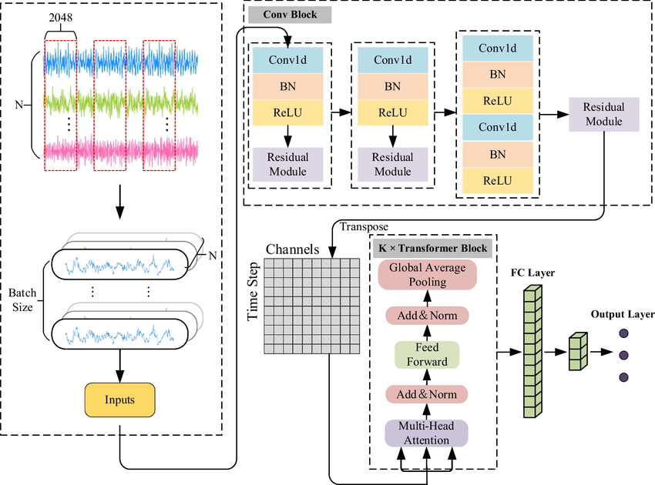
Figure : Example of a CNN to Transformer Architecture
One problem Transformers have compared to LSTMs is that they don’t have a natural understanding of temporal or spatial differences. Therefore, to help the Transformer model understand the relationship between the clips, a positional encoding step will be added between the CNN and the Transformer, providing the frames with a learnable parameter that maintains the temporal flow of the swing. This step is needed because if we were to pass a set of four frames (f1, f2, f3, f4) from the CNN to the transformers section without it, the transformers wouldn’t understand the difference between the actual sequence and another sequence of the frames (e.g., f4, f1, f3, f2). After this step, the model will then again understand the positions of the frames relative to each other and be able to give better results. Both models will be tested in this paper to determine which architecture yields better results.

REFERENCES
- Foundation, N.G. (no date) Golf Industry Facts, The Clubhouse. Available at: https://www.ngf.org/the-clubhouse/golf-industry-research/.
- McNally, W. et al. (2019) GolfDB: A video database for golf swing sequencing, arXiv.org. Available at: https://arxiv.org/abs/1903.06528.
- Australian Golf Digest (2022) Swing sequence: Cameron Smith, Australian Golf Digest. Available at: https://www.australiangolfdigest.com.au/swing-sequence-cameron-smith/.
- Golf swing tips - fully illustrated - perfect golf swing (2024) Golf Distillery. Available at: https://www.golfdistillery.com/swing-tips/
- MARAIS, M. (2022) GolfDB original videos, Kaggle. Available at: https://www.kaggle.com/datasets/marcmarais/videos-160.
- Ji, L., Zou, Y. and Zhu, K. (2019) The structure of the hybrid CNN-LSTM model as shown in figure 1,... | download scientific diagram, Research Gate. Available at: https://www.researchgate.net/figure/the-structure-of-the-hybrid-CNN-LSTM-model-As-shown-in-figure-1-CNN-LSTM-model-consists_fig1_338284041
- The architecture of the transformer-CNN network | download scientific diagram (2024) Research Gate. Available at: https://www.researchgate.net/figure/The-architecture-of-the-Transformer-CNN-network_fig2_340010963.

